Session 19

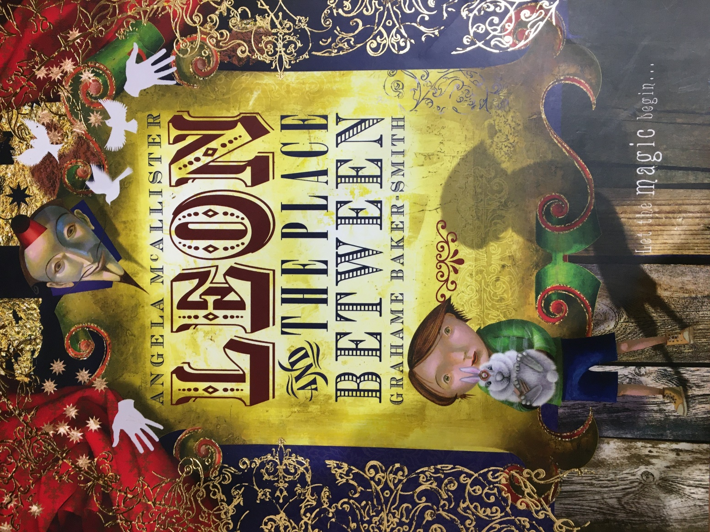

- This is the front cover of the book, revealing the title. Does the title surprise you?

Today, I would like you to reflect back on the whole text. Re read the book from the start and then fill out the Tell Me Grid below…

Think about what you liked and disliked. Then think about anything that puzzles you and anything that the story reminds you of.

Likes: | Dislikes:
What puzzled you? What questions would you like to ask the author? | What does the story remind you of? This could be a personal experience, book or film.

