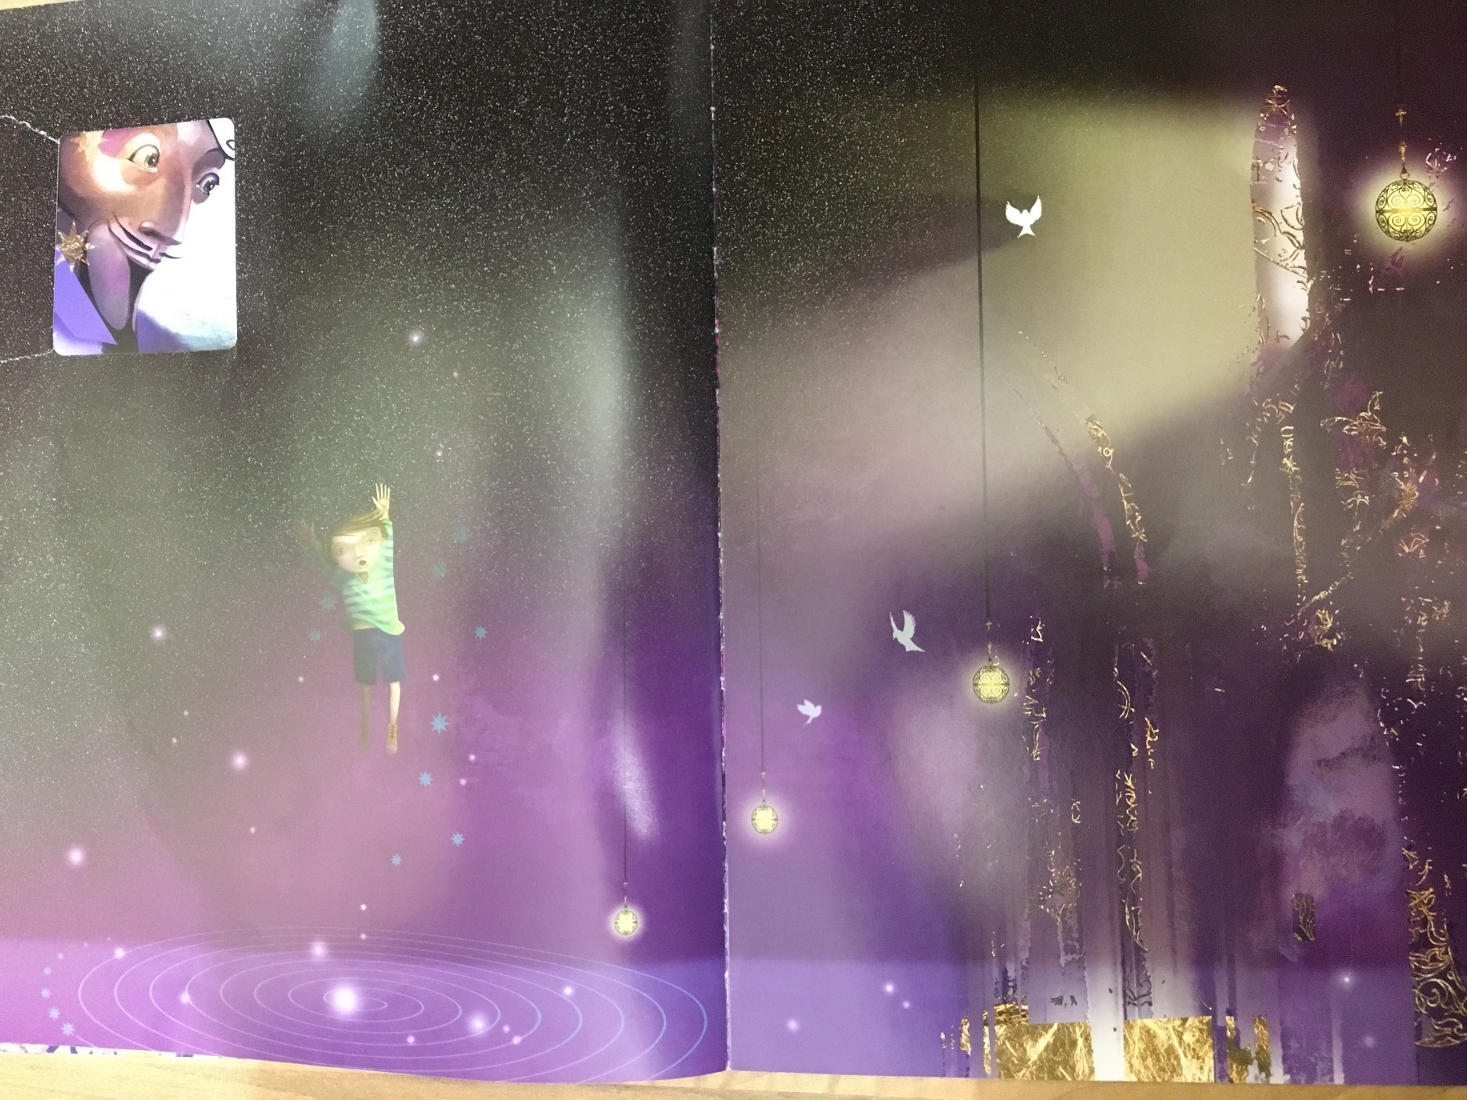
Session 13
- Look at the next page…
Today’s session is mainly discussion based – you could write your ideas around the outside of the images

- What do you think is happening to Leon? Where is he? Do you think he’s pleased with his decision to volunteer? What can you see in the image? What do you think is going to happen next? How do you think the other children and the audience are feeling?

- You will see that you can still see Abdul Kazam in this image through a small square (door of the box). What do you think of this? Why do you think the author and illustrator chose to cut a square out the page?

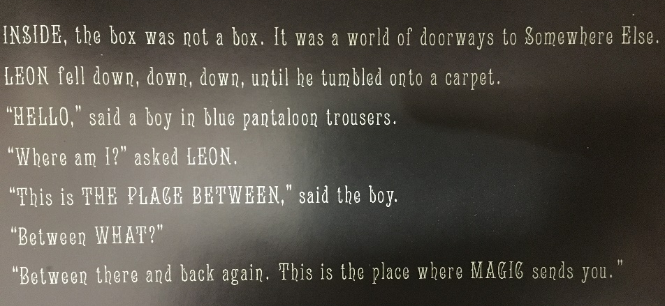
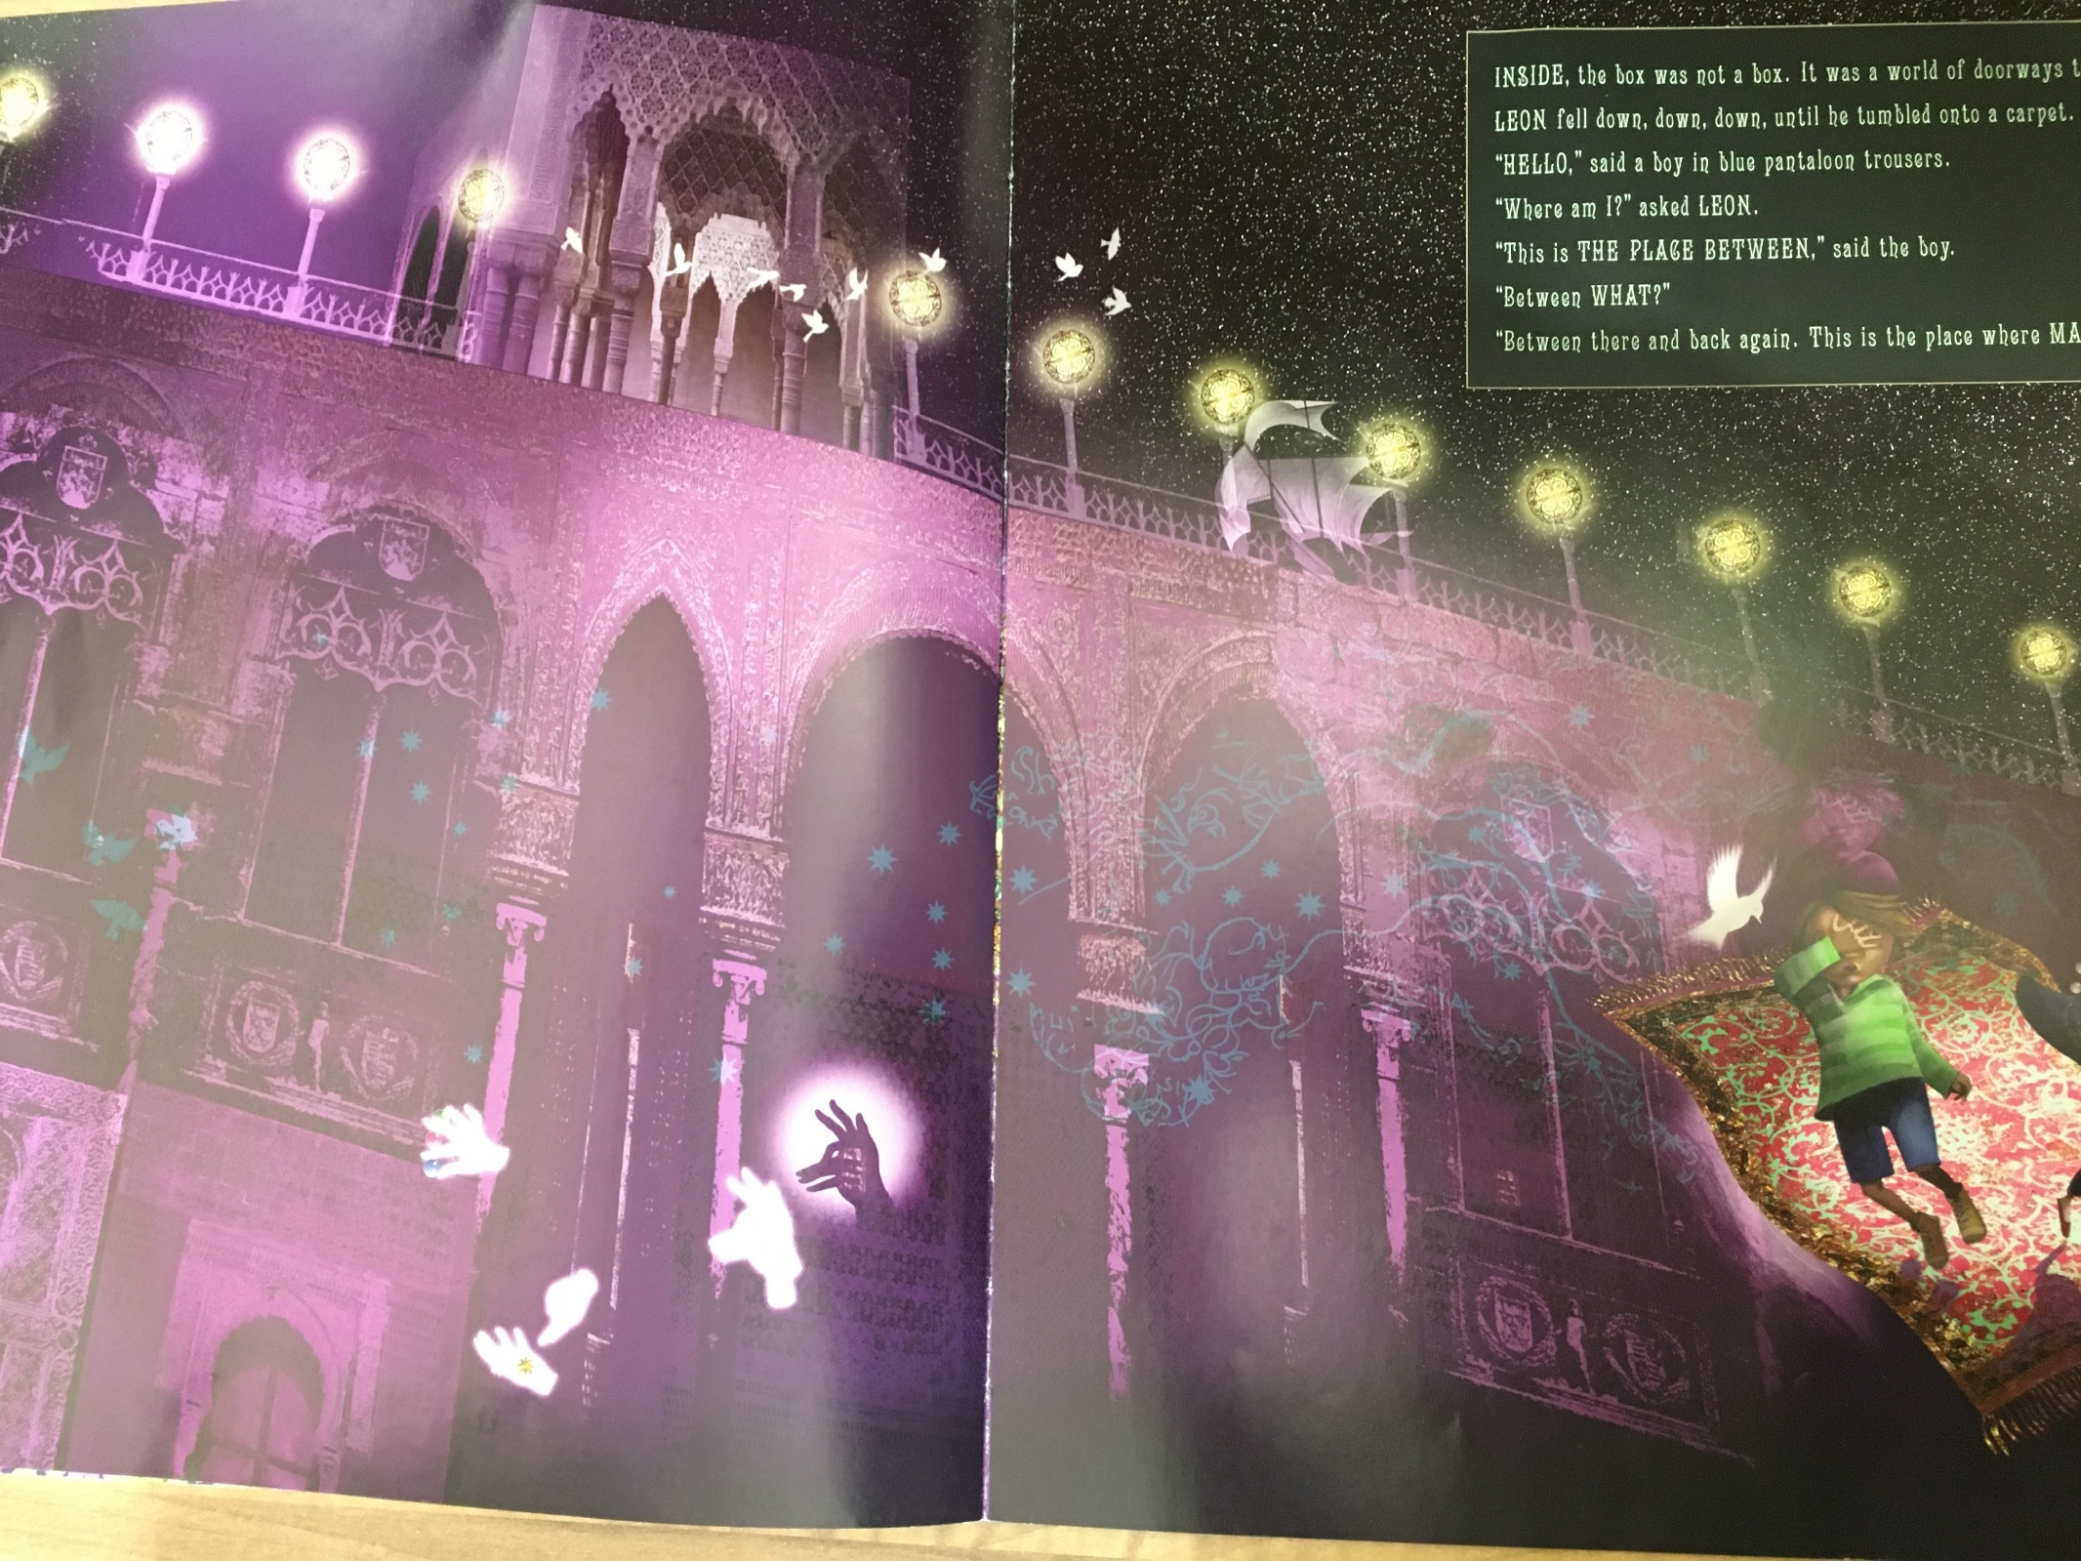

- What do you think about this place now? What ‘magical objects’ can you see? Who do you think this new character is? How do you think he got here? What do you think might be through the doorways?

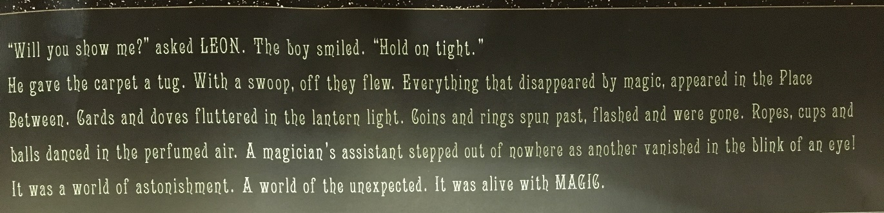
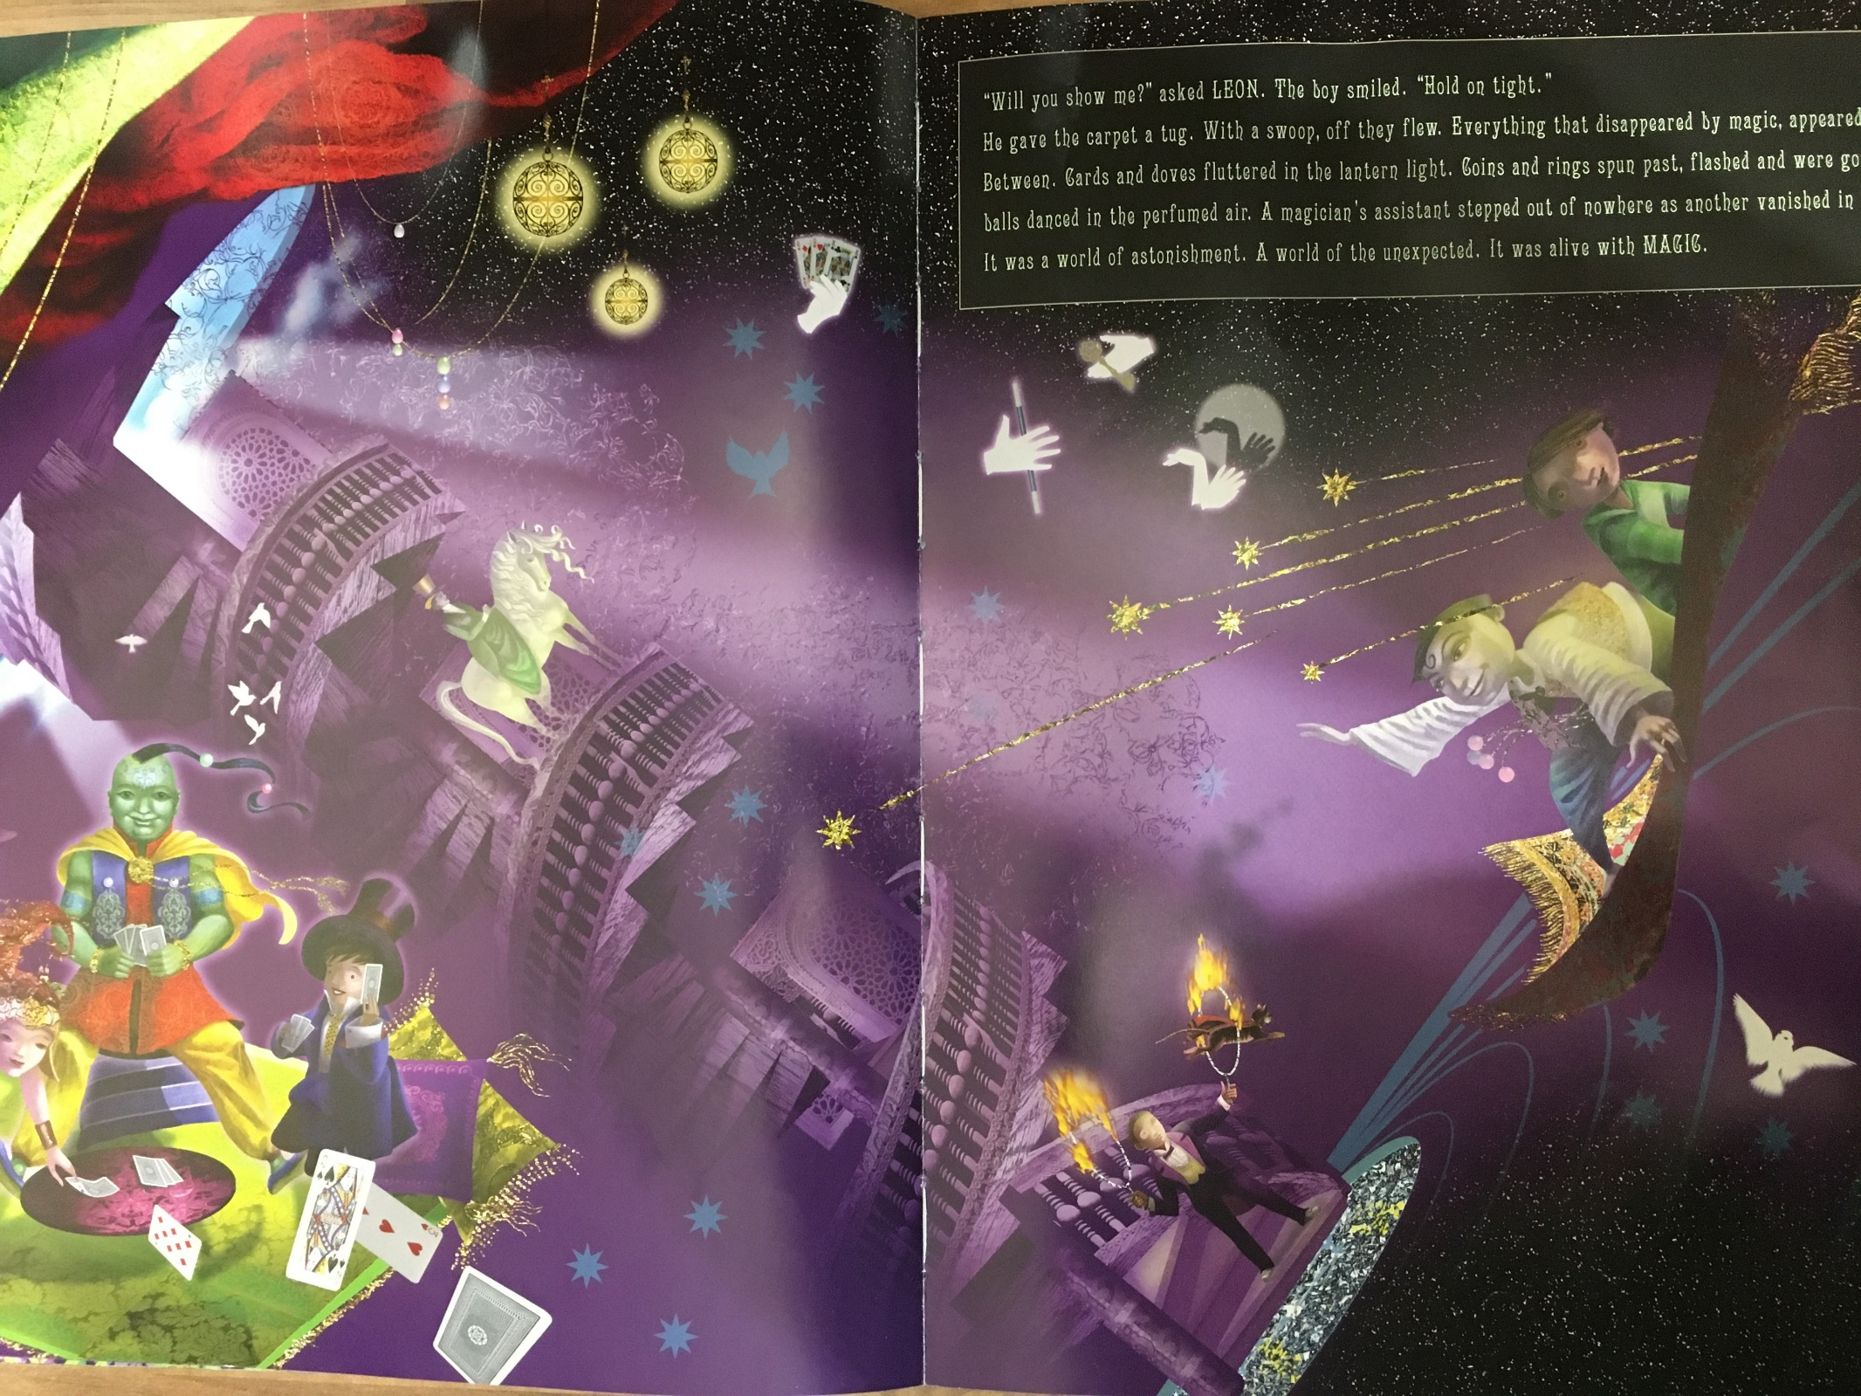

- What can you see now? What connections do you make with the objects and characters? Can you link any of what you see to other books or films you’ve seen? What do you like/dislike? How do you think Leon is feeling now?

