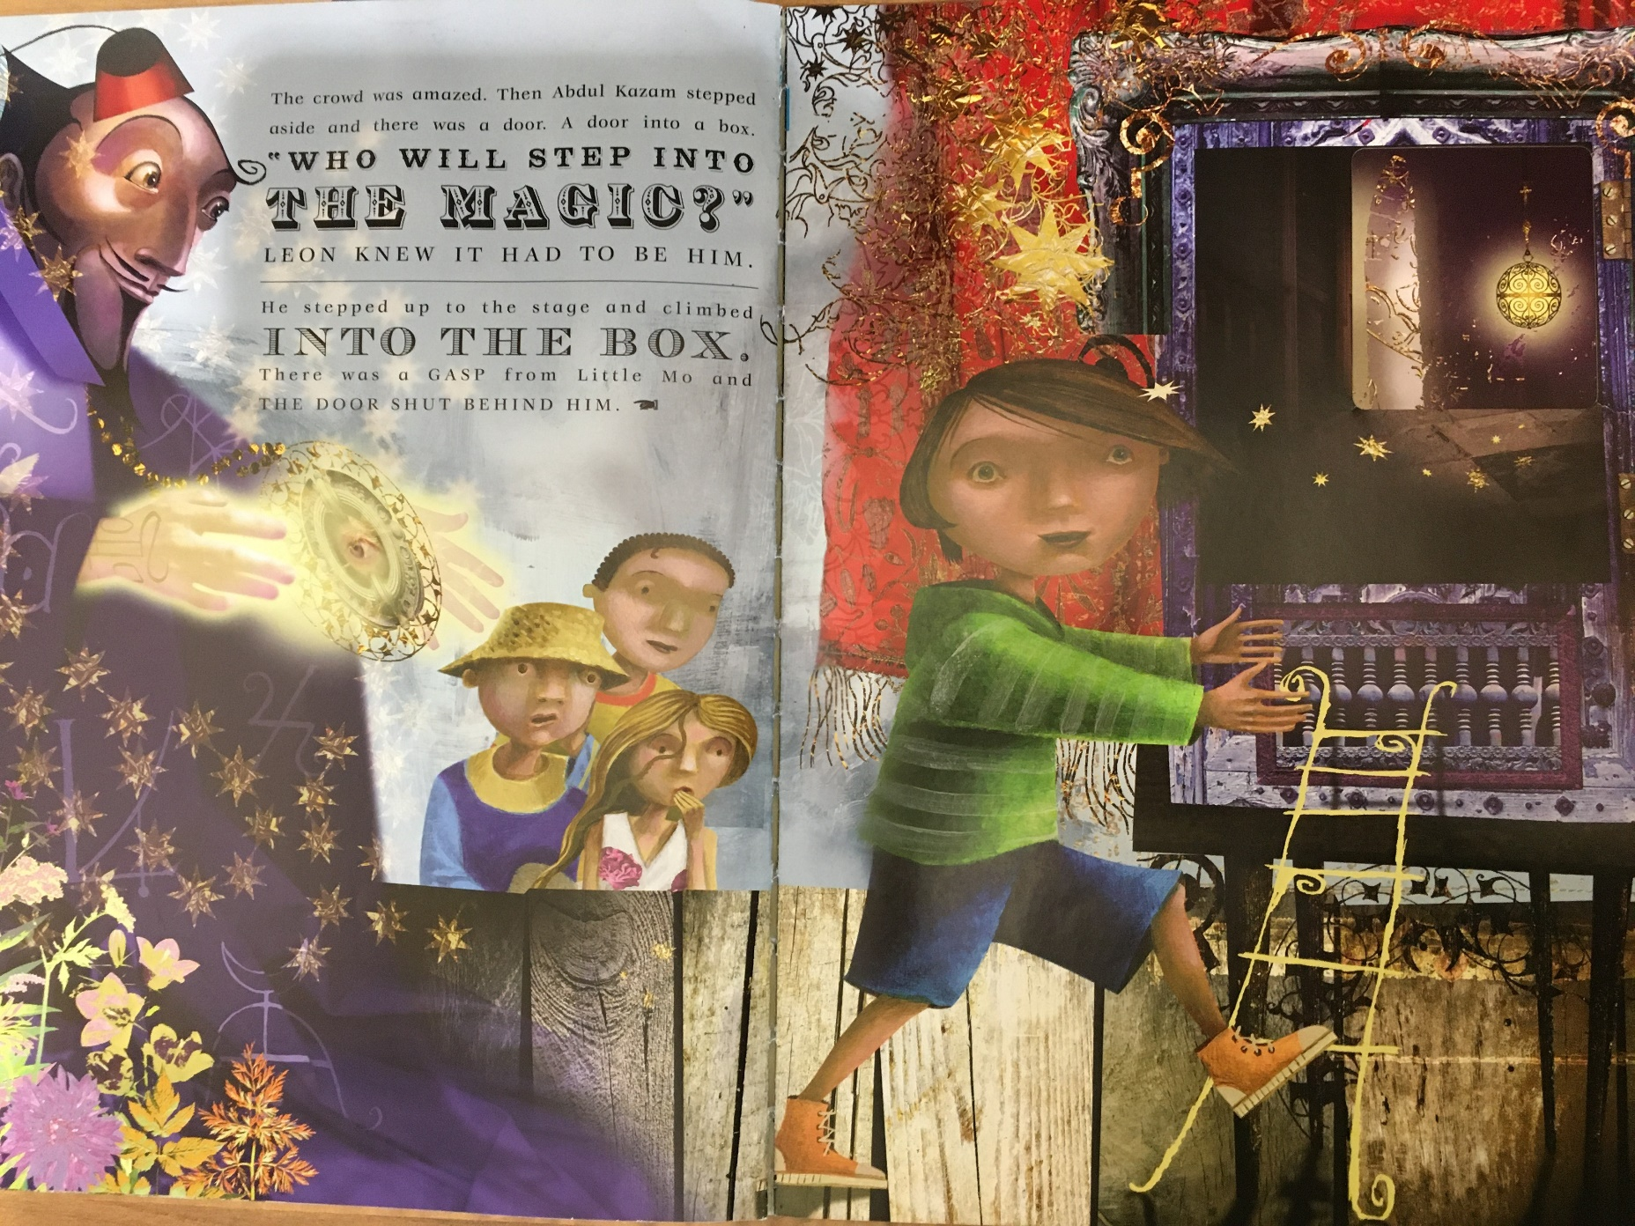
Session 12
- Look carefully at the next illustration and text. What can you see? Why do you think Leon stepped up? How do you think the others are feeling? How do you know this? What do you think about Abdul Kazam? What do his facial expressions tell us? How does Leon look? What do we learn about him? (you could add this to your role on the wall from earlier)

- Choose one of the other children and write a short diary about how they are feeling at this moment as their friend Leon approaches the box. Are they excited or worried for him? Are they jealous?

