Session 5
Read the next pages:
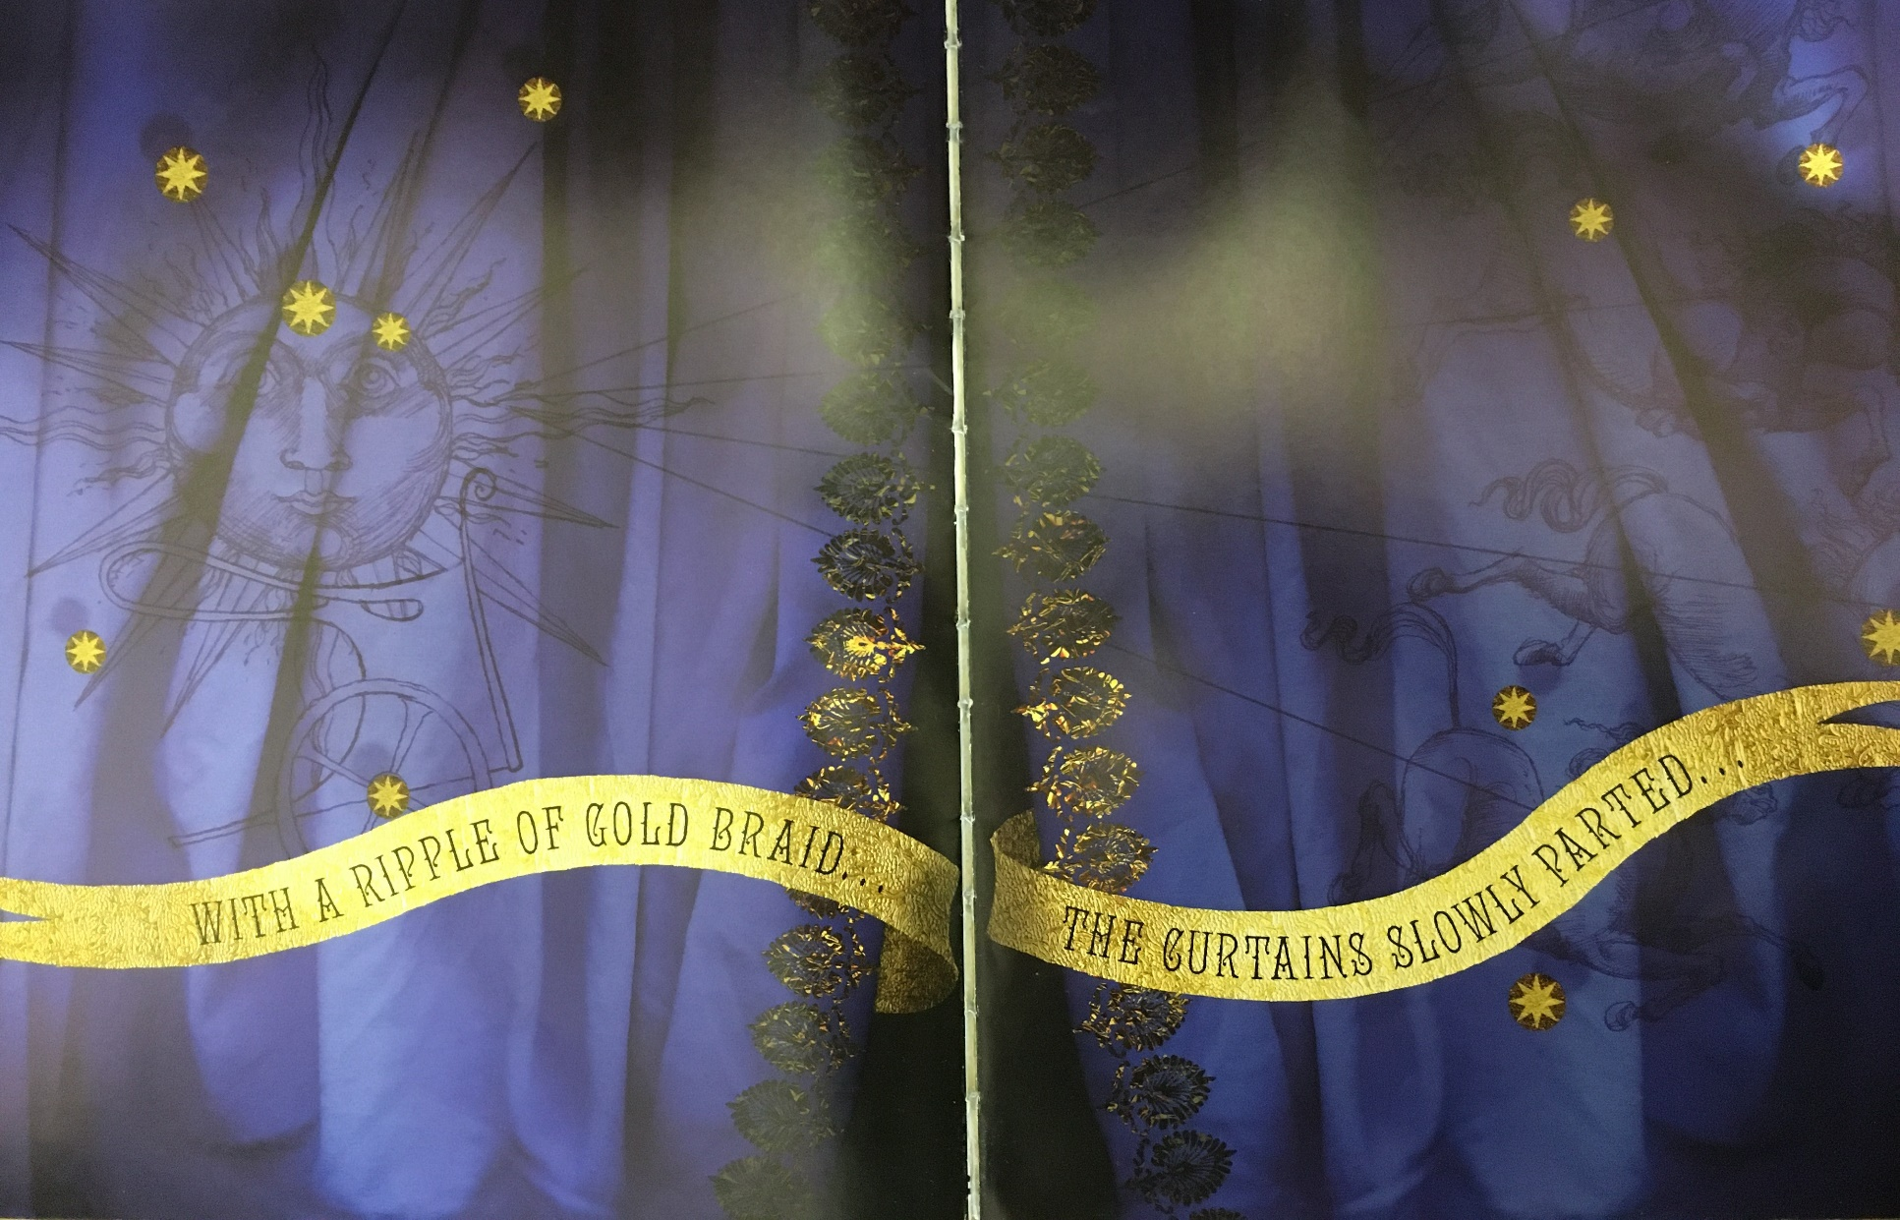

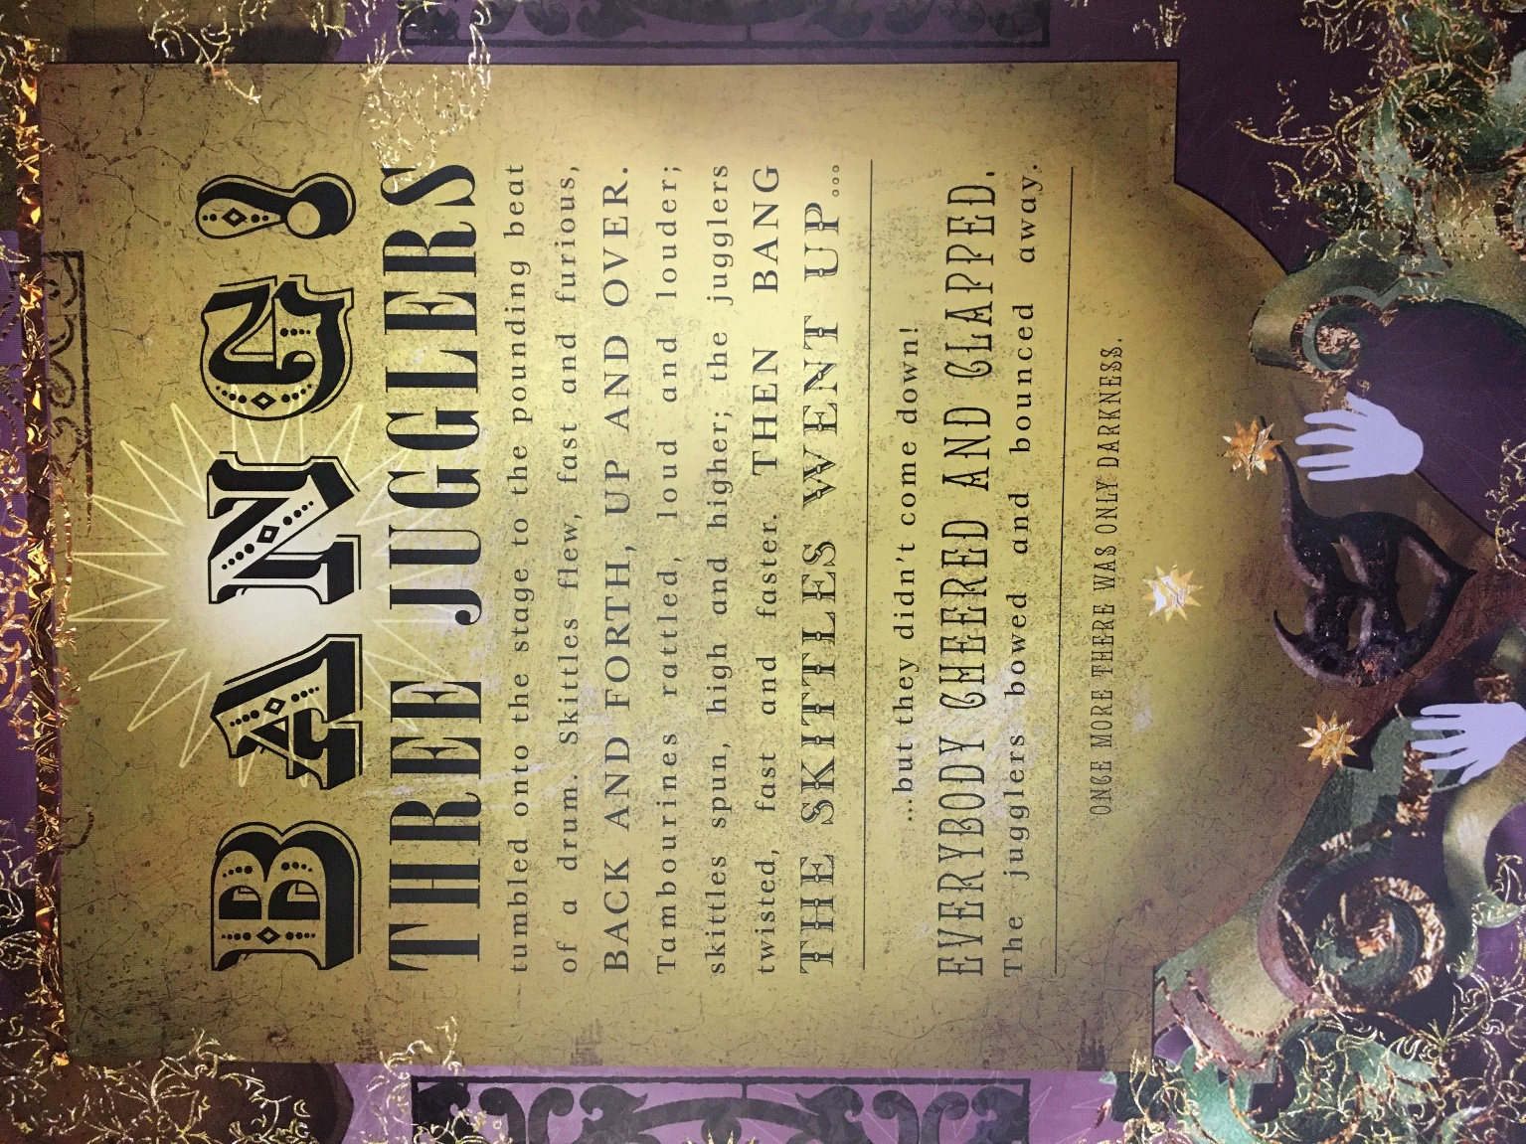
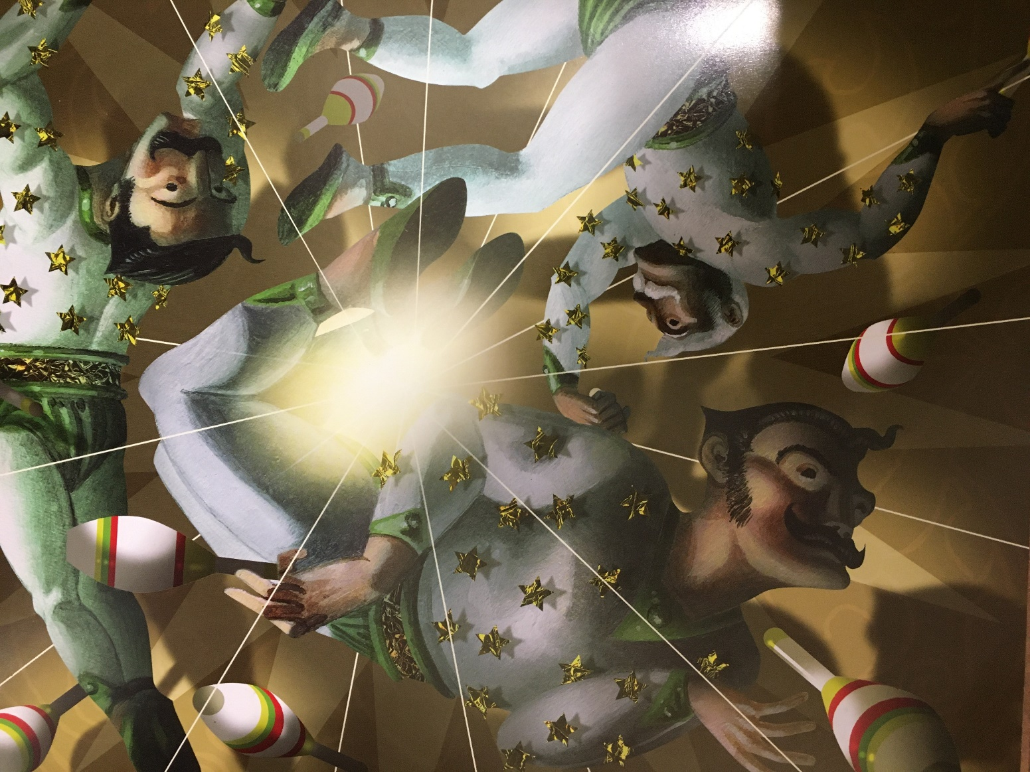
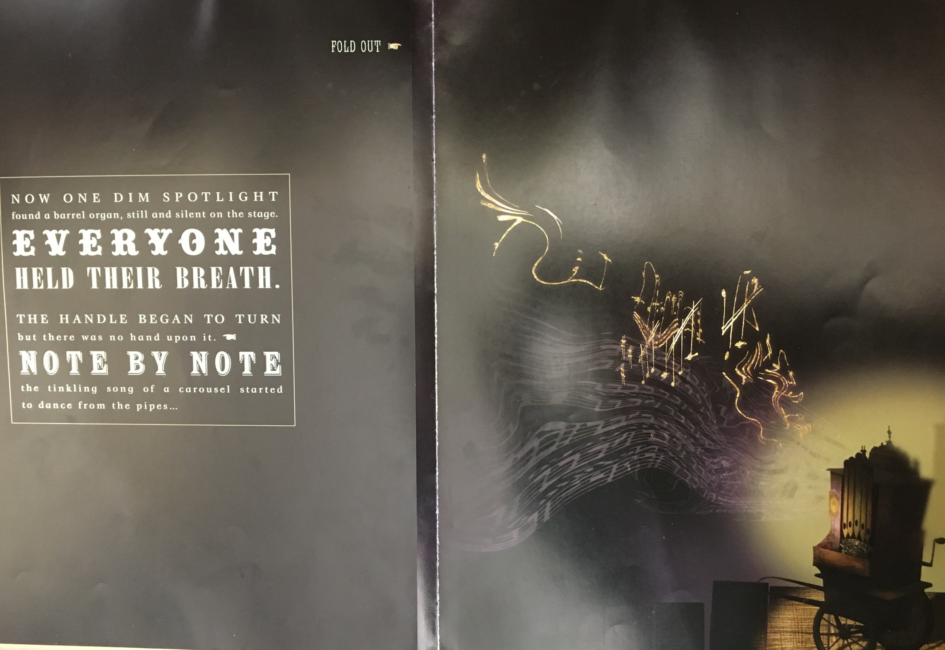
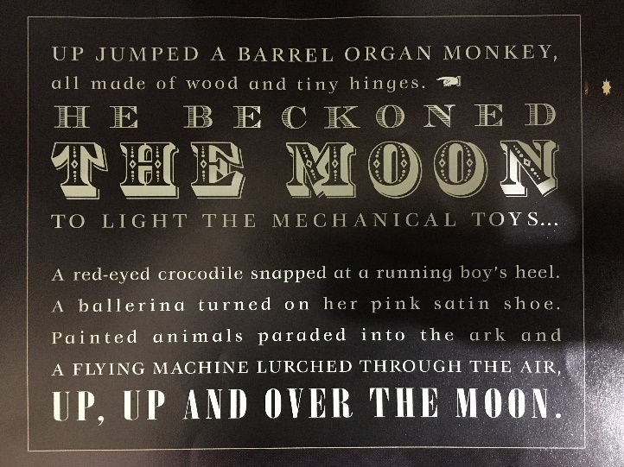
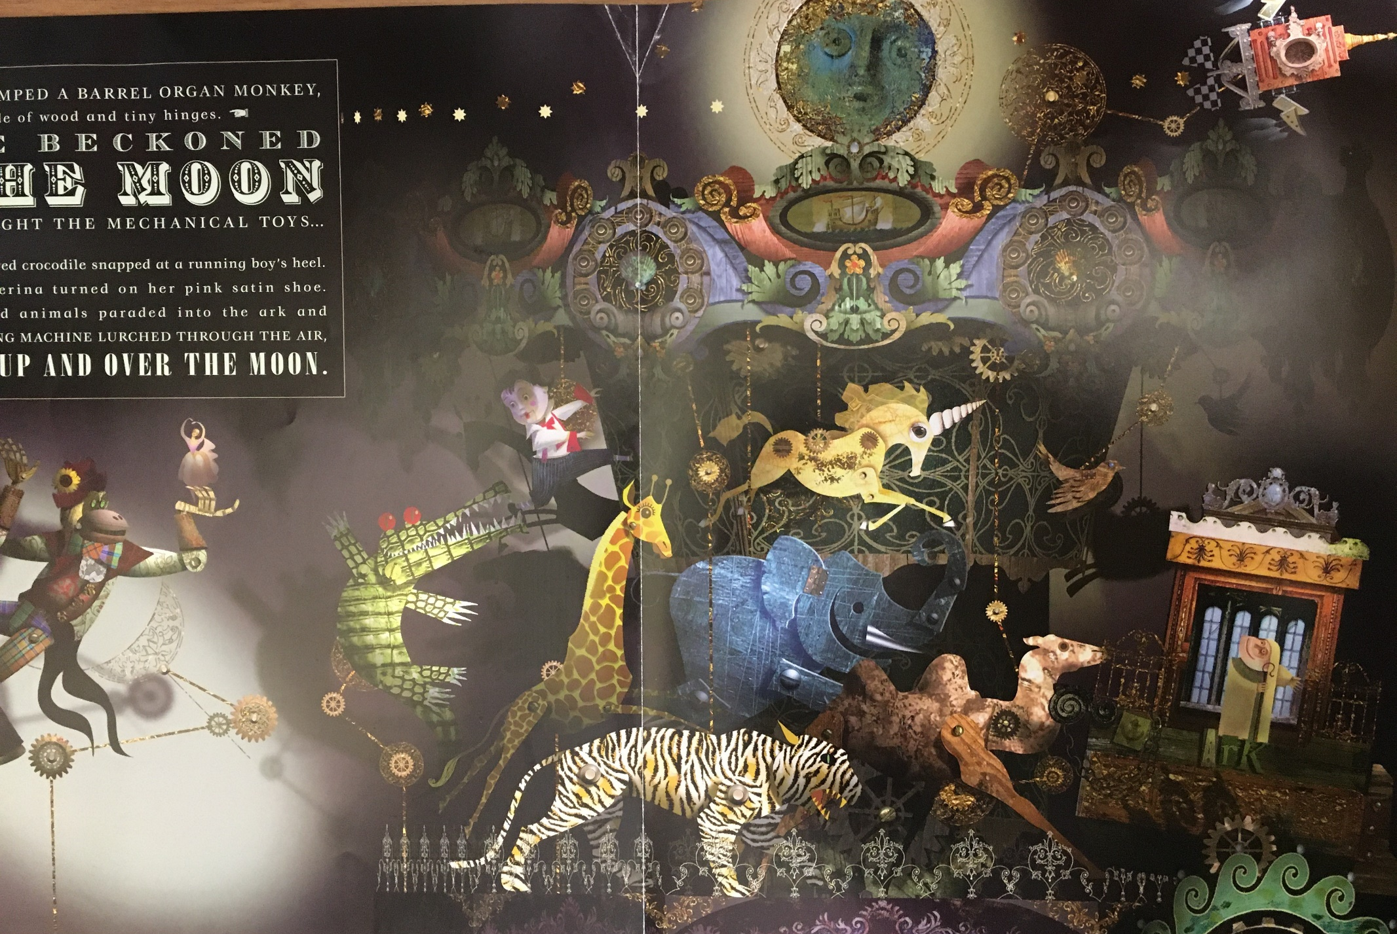
- Read the text again and pick out words and phrases that make the experience exciting for the reader. For example, ‘the pounding beat of the drum’ and ‘everyone held their breath’. Think about why you have chosen those phrases. Have you noticed how the author and illustrator use different fonts and size of writing? What do the illustrations tell us? What can you say about how the author and illustrator work together to create the atmosphere – think about the way ‘with a ripple of gold braid…’ is written.

- Today you are going to do a performance reading of the text so get all the family involved! Video evidence would be lovely

- I have put a copy of the text on the next page – use this to write on and mark how you’re going to perform it. Think about actions, props, voices…
o Which parts might be read in unison?
o Which words could be performed in different ways to enhance the reader’s understanding of the meaning?
o Which bits might be read with one voice/two voices?
o Which bits might be read loudly/softly/echoed?
o Might you include sound effects?
o Might you perform actions?

Have fun – dressing up is optional!

Section 1:
BANG!
THREE JUGGLERS
tumbled onto the stage to the pounding beat
of a drum. Skittles flew, fast and furious,
BACK AND FORTH, UP AND OVER.
Tambourines rattled, loud and louder;
skittles spun, high and higher; the jugglers
twisted, fast and faster. THEN BANG
THE SKITTLES WENT UP...
but they didn’t come down!
EVERYBODY CHEERED AND CLAPPED.
The jugglers bowed and bounced away.

Section 2:
ONCE MORE THERE WAS ONLY DARKNESS.
NOW ONE DIM SPOTLIGHT
found a barrel organ, still and silent on the stage.
EVERYONE
HELD THEIR BREATH.
THE HANDLE BEGAN TO TURN
but there was no hand upon it.
NOTE BY NOTE
the tinkling song of a carousel started to dance from the pipes…

Section 3:
UP JUMPED A BARREL ORGAN MONKEY,
all made of wood and tiny hinges.
HE BECKONED
THE MOON
TO LIGHT THE MECHANICAL TOYS...
A red-eyed crocodile snapped at a running boy’s heel.
A ballerina turned on her pink-satin shoe.
Painted animals paraded into the ark and
A FLYING MACHINE LURCHED THROUGH THE AIR,
UP, UP AND OVER THE MOON.

