Session 3

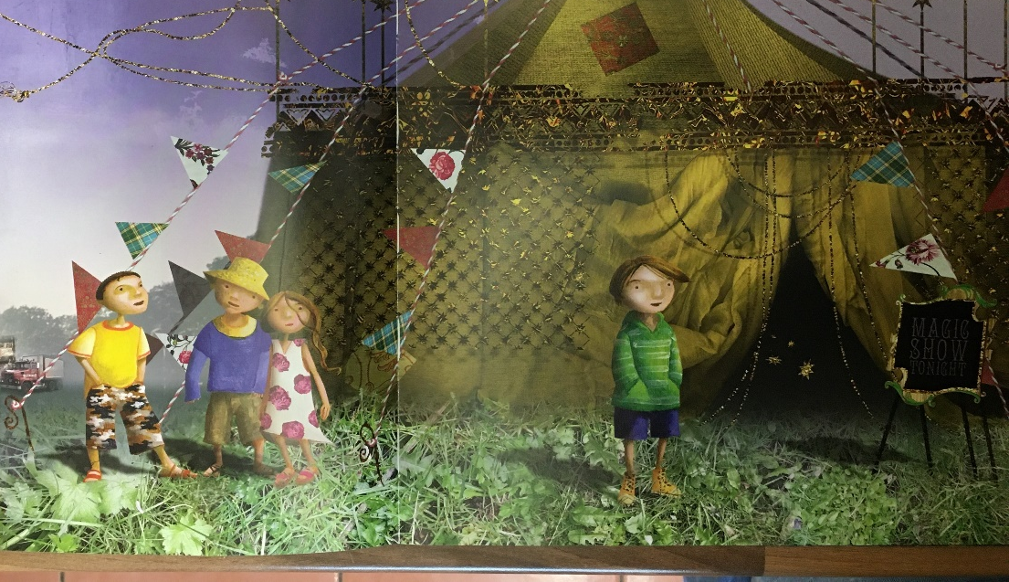
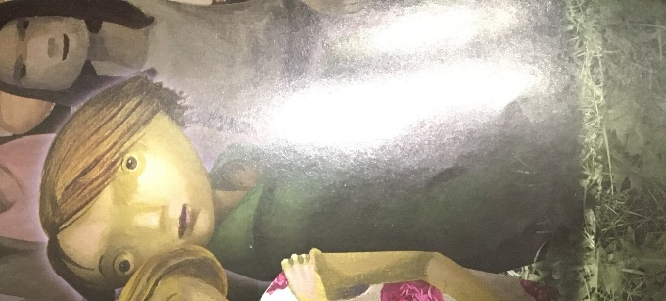
Today we will create a role on the wall for Leon.

- Draw a large outline of Leon.

- Record your ideas on your drawing. Remember we write words and phrases about his appearance around the outside of the drawing and words to describe his feelings and personality on the inside.

- What do we know about him so far? How do you think he’s feeling? What do his facial expressions tell us? Why might he be feeling like this? Have you ever felt similar? Why do you think he is separated from the group in the first picture as they enter the tent?

- You could write some sentences to create a short character description of Leon

- Make a prediction – where do you think the story is going to take Leon?

